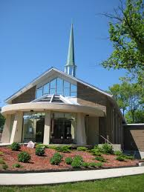
St. Paul’s United Church, Cliffside.

Summer Student Opportunity!

St. Paul’s in the Cliffside neighbourhood on the Scarborough Bluffs is seeking a self-starting, initiative-taking, creative, and versatile individual as a summer placement for the position of “Summer Program Animator.”

The summer program consists of a series of workshop / seminars for seniors, and a GO PROJECT Adventure Camp for Kids. Other summer objectives and tasks may include research and analysis of needs in the Cliffside area, assisting in identifying opportunities for mission and ministry, developing and organizing the community archives housed at SPUC, and social engagement with the neighbourhood. While that sounds like a lot, we can discuss how these tasks and priorities can be arranged to mesh with your learning goals, interests, and talents.

The position is for 32 hours a week for 12 weeks, with flexibility in scheduling. Hourly rate for this contract is $18.00. If possible, we’d like to have the new hire in place by the first of June.

Contact Daniel Benson at St. Paul’s: 416-261-4222 revdanielb@gmail.com .
www.stpaulsscarborough.org

